**Overview**

This project is about transforming traditional clinical simulation training centers into a VR experience. The objective is to help medical students in resource-limited areas attain higher quality clinical simulation training. It requires a lot of research and analysis of user behavior.

**Product Story**

**Problem**:   
There is a lack of high-quality medical education resources ( specifically clinical simulation training centers) in Sudan.

Nadia Ahmed is a post-graduate medical student. She studies at the University of Khartoum, which is the best medical school in Sudan. She works really hard on her studies because becoming a doctor has always been her dream. She would like to pursue cardiovascular surgery after graduation. Right now, she is taking a course related to this area. The course requires her to participate in simulation training 3 - 4 times a week. She loves simulation training as she thinks it is a great way for her to practice her knowledge and get more familiar with responding to emergencies. However, she is unsatisfied with the low-fi simulation environment. Due to financial reasons, the university’s clinical simulation training situation is really poor. There are some dedicated rooms for simulation training but those rooms only have beds, low-fi mannequins, and basic medical equipment.

On the other hand, in a developed country like Canada, there are advanced simulation centers that provide dedicated instructors and high-tech training equipment to medical students for the purpose of getting hands-on practice. These simulation centers are extremely expensive and have limited capacity. But for obvious reasons, Nadia does not have access to this type of training.

**Solution:**

Virtual Clinical Simulation (VCS) can solve this problem for Nadia. VCS is a VR medical education tool that provides clinical simulation training to medical students around the globe.

Instead of having to physically attend a simulation center, clinical training happens in the virtual world. By simply putting on the VR headset, students enter into a virtual medical environment to participate in a simulated training session. The environment is designed after a real-world medical environment and in the simulation, the patient is even more life-like than a mannequin. VCS also supports multiple students training at the same time. Unlike traditional training centers where the instructor needs to be in the same place as the trainees, VCS allows the instructor and the trainee to be in two different locations. The instructor can use their PC to control the simulation process, see the real-time situation in the VR environment, and communicate with the trainees. This solution eliminates the barriers of distance, time, personnel and financial burdens to benefit medical students in developing countries and rural areas.

In addition, compared to advanced simulation centers that cost millions of dollars, each VR headset only costs hundreds of dollars, which is an economic solution.

By using VCS, Nadia has the opportunity to access better quality medical training and a chance to receive instruction from top medical practitioners from around the world. Now, she is one step closer to achieving her dream.

**Research**

**Define the problem**:

The quality of clinical simulation training for medical students in developing countries and rural areas is extremely low.

**Target User:**

We have two types of target users: medical students in developing countries and medical training instructors.

Below are the user persona of these two target users.

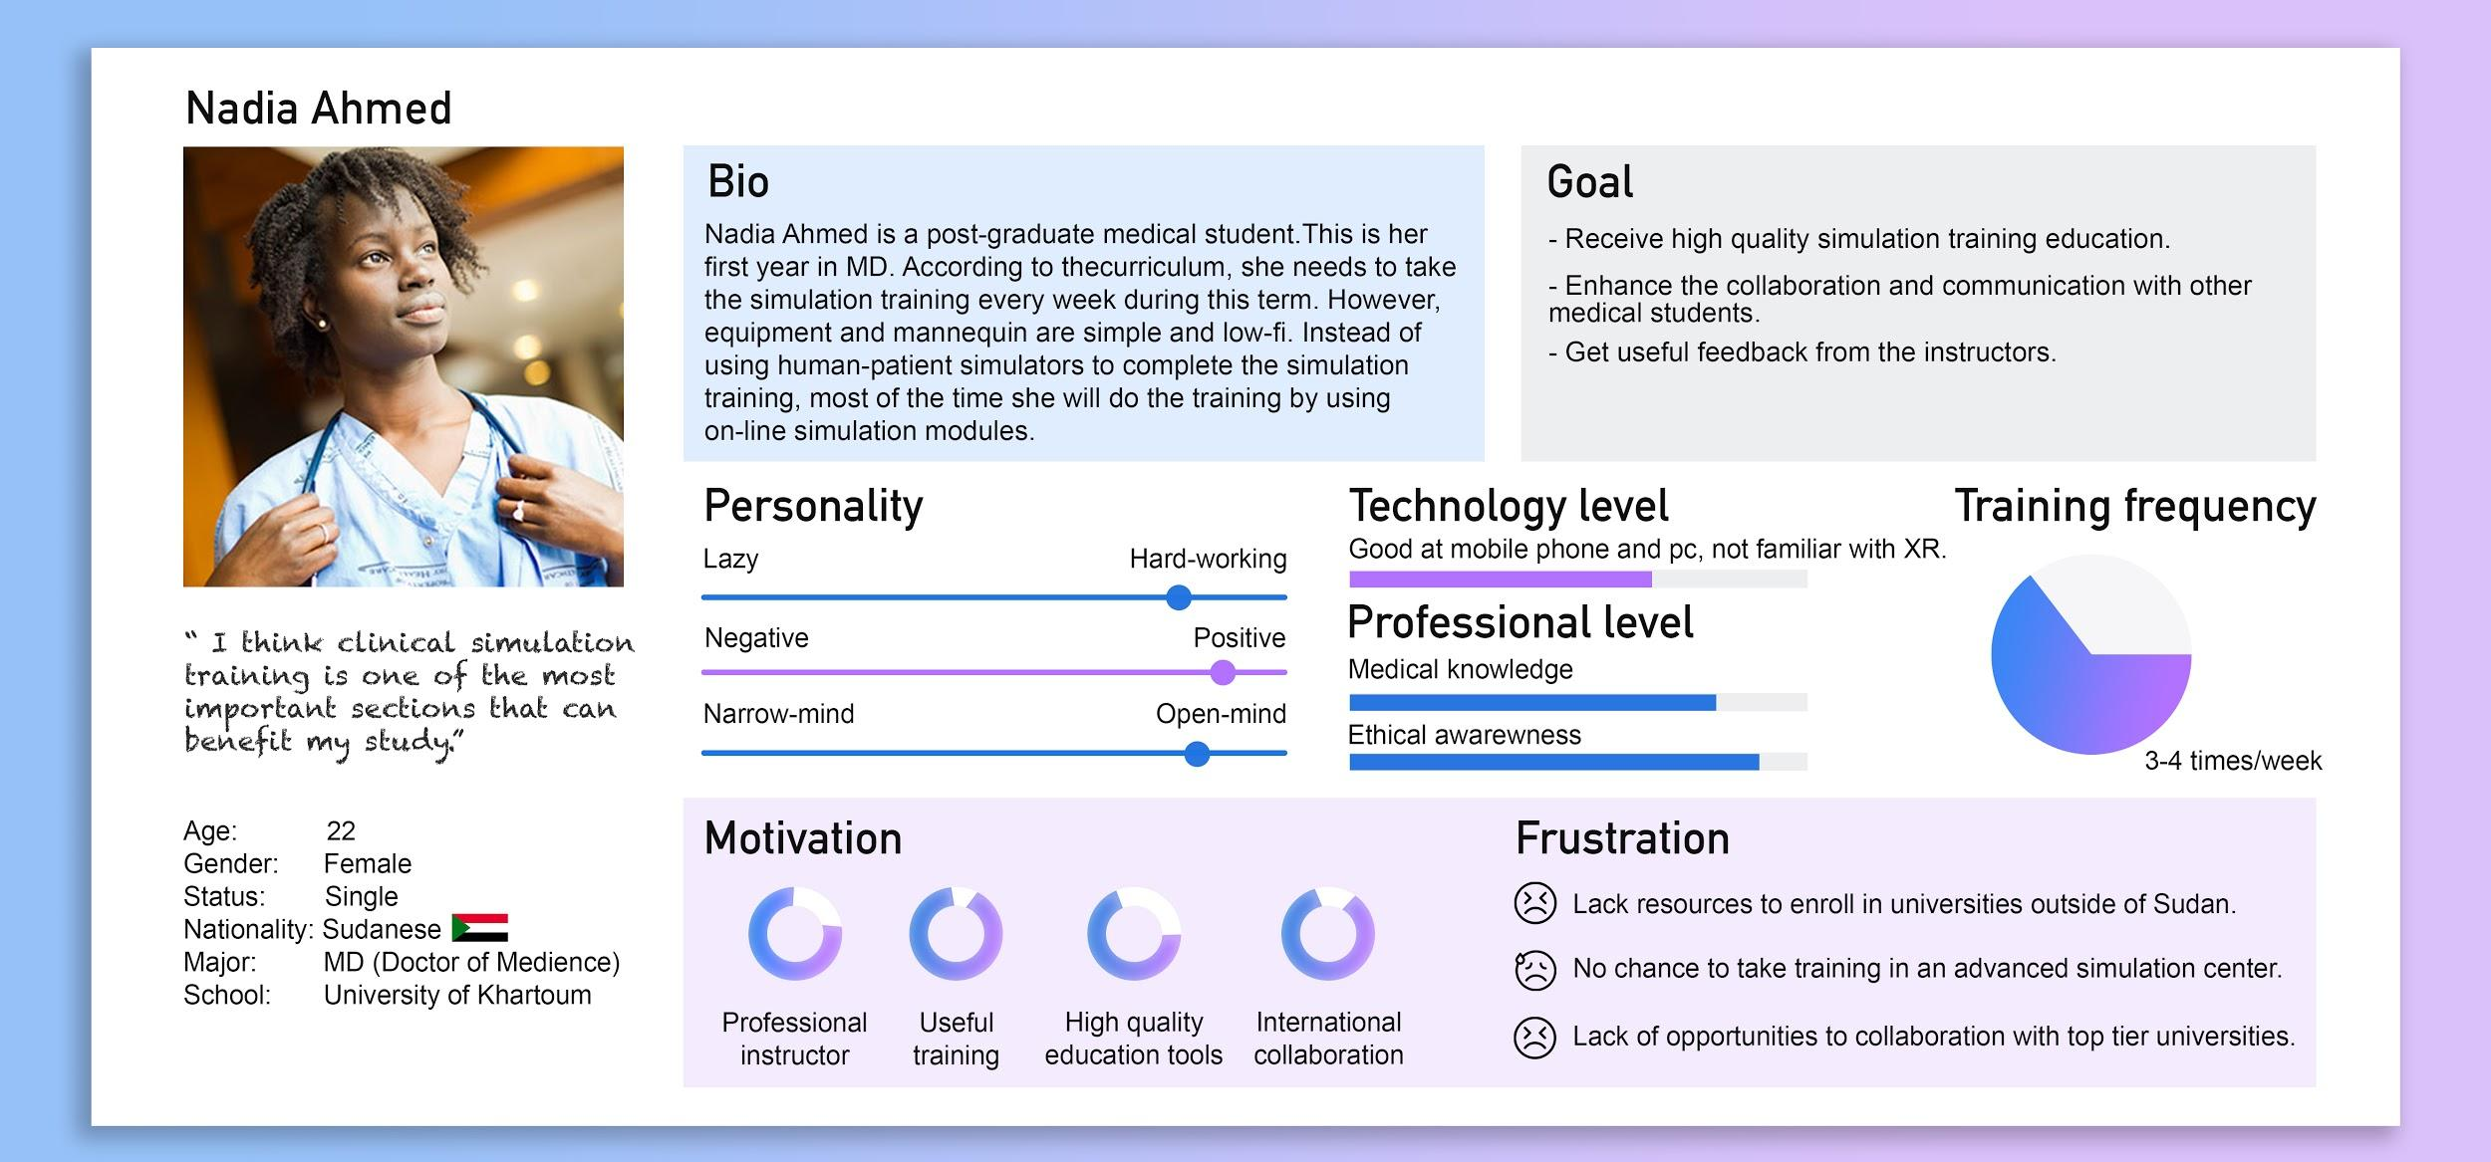

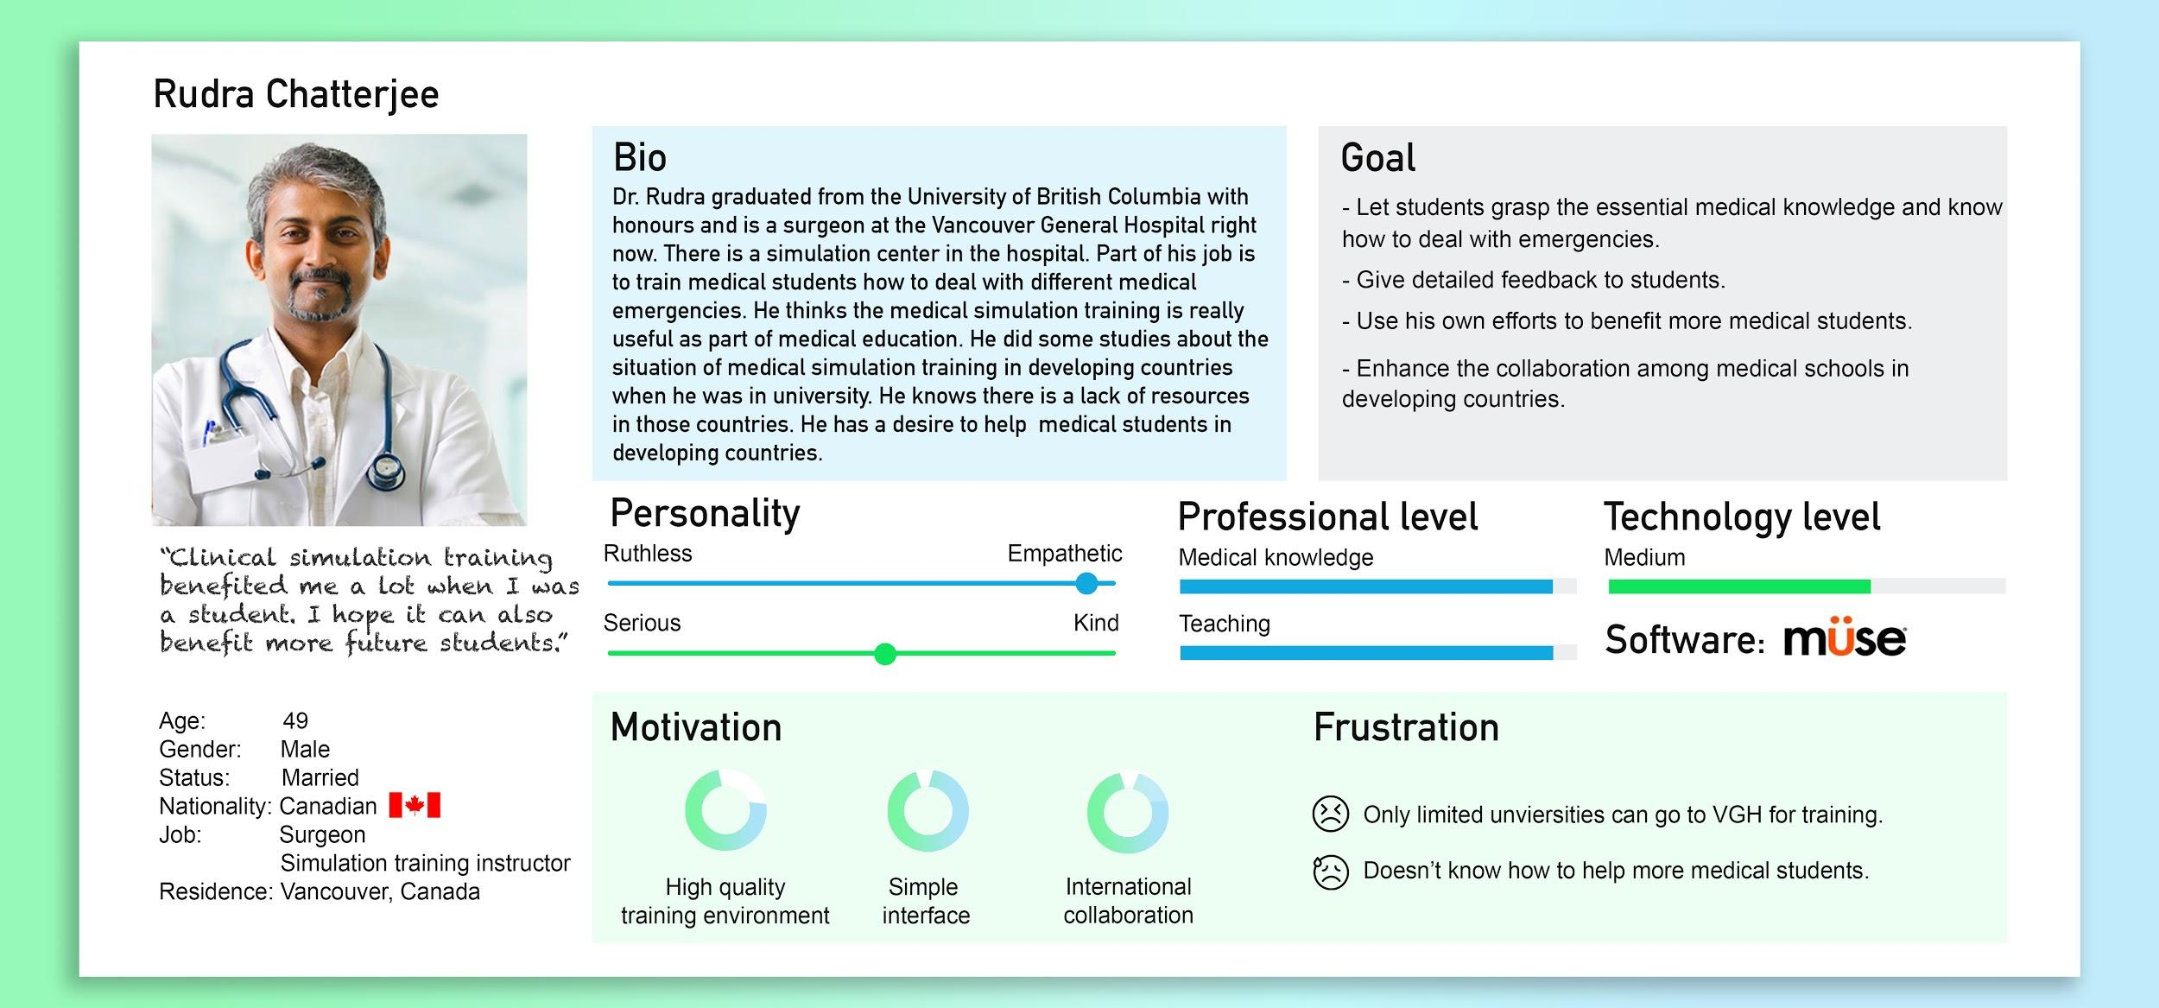

**Site visits:**

We visited the VGH (Vancouver General Hospital) Simulation Center to understand how clinical simulation training works currently. Right now it is all a physical process. The students and instructors need to be in the same location. The instructor will remain in a small room behind a one-way mirror and use a dedicated software tool to control the high-fi mannequin and vitals. Students take action according to the situation. There are monitors to record the process of training in the room. Instructors will show the recording video and review the process with the students after the training session is complete. The simulation center is used for high-quality medical simulation training, however; in developing countries, there are fewer simulation centers due to financial constraints.

**Design Process**

**User Journey:**

We analyzed the normal steps that the medical students take to participate in simulation training and created a user journey map. According to the journey map, we decided to focus on designing the training itself, implementing it in a VR environment and allowing the instructors to control the simulation from a PC.

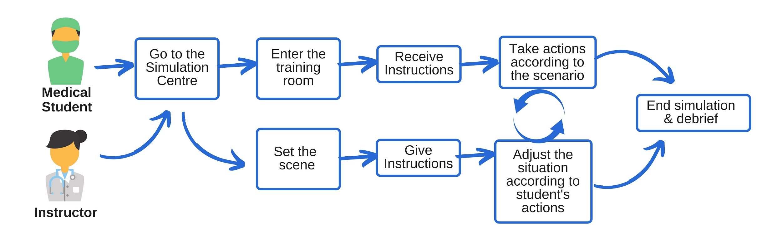

After we determined the design content, we started to design the wireframe. We separated them into two parts which are the instructor’s control panel and VR interface.

Then we made a user journey for our prototype to understand what functions need to be included and what is the contact point.

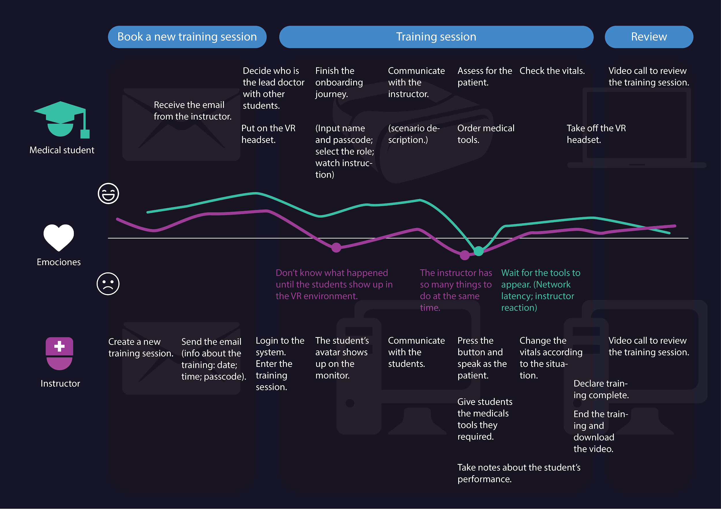

**User Flow:**

Below is the user flow of these two parts.

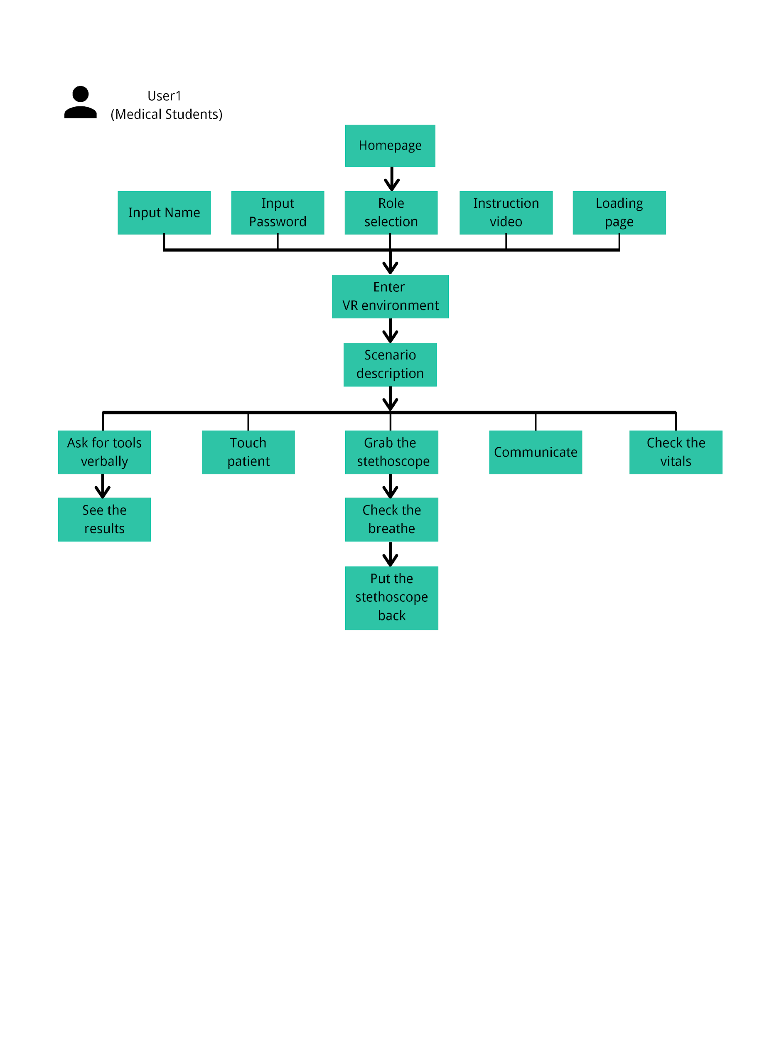

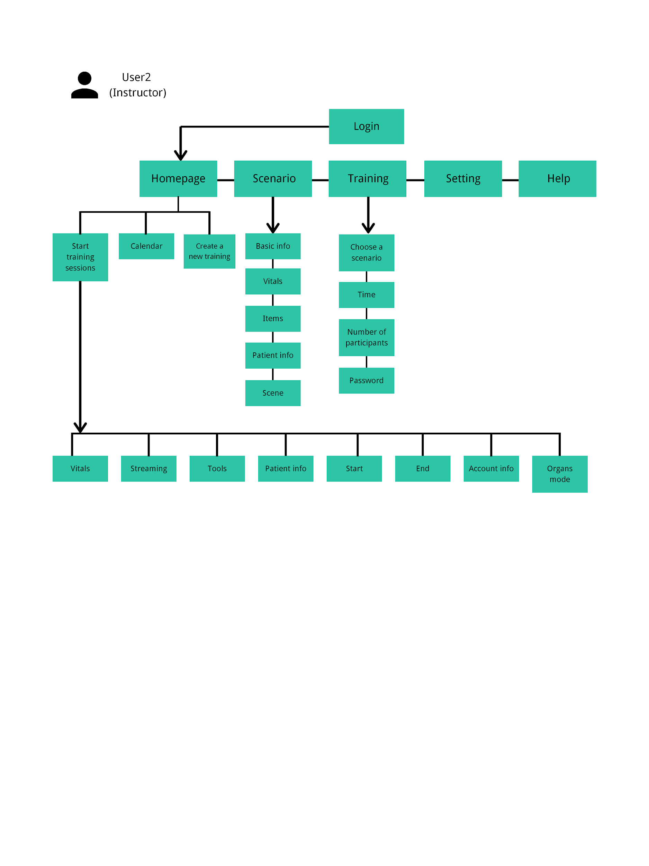

**Wireframe:**

According to the user flow, we designed the wireframe. The inspiration comes from the application used by the VGH Simulation Center right now. Because we want the instructors can know how to use it quickly so we tried to make the interface simple and clear. We have iterated several times according to the user test results. This is part of the final version of the wireframe. For the whole wireframe, please see the appendix.

|  |  |
| --- | --- |
| Control Panel -1 | Control Panel - 2 |
| Log In | Dashboard |

**Usability Test**

The original plan was five usabilities tests：control panel wireframe test (twice); VR prototype test; functional control panel test; complete prototype test. However, because of the COVID-19 situation and the university policy, the final test had to be canceled. We only tested the complete prototype with ourselves and our client to uncover some essential changes.

The below form is the four test results and conclusions. All raw materials will be in the appendix.

|  |  |  |  |
| --- | --- | --- | --- |
| No. | Test details | Result | Conclusion |
| 1 | This test is about the interface that the training instructors use. We designed the wireframe about the control panel and the basic frame of this application. The goal is to see if this wireframe shows each function clearly and intuitively.  Date: Feb 5th, 2020  Location: Project Room 1  Test sample: 10 students  *(Survey + Observation)* | * 50% of testers think the user journey is intuitive; 40% of testers are not very determined it is intuitive; 10% of testers think it is not intuitive, he thinks we give too many instructions. * 90% of testers think our wireframe is easy to understand for most of the parts. * 50% of testers need to read the words under the icons to help them finish the tasks. * 80% of tester think changing different modes is the hard part for them. * 60% of tester think to activate the first tool is the hard part for them. * According to the observation, 4 people got hesitated when they were asked to end the simulation; 3 people missed the first part of “start the simulation”. | * Use colors to show the ON/OFF situation. (UI) * Switch the ON/OFF situation to show their current situation. Or change it to another layout. * Enlarge the “next” icon in “Create a new simulation” part and add text “next”. * Put the “Organs” button on the same place with the mode switch button. * Add some explanation on the “start” and “end” button. * Change the audio connection. * Add more connections. * Emphasize some icons and text which are going to be activated in our real product. |
| 2 | This test is to verify if the changes from the last test are helpful for users to use the wireframe.  And also trying to found other improvements.  Date: Feb 12th, 2020  Location: Project Room 1  Test sample: 5 students  *(Interview)* | * 100% of users agreed that the wireframe was easy to use. * 100% of users thought the user journey in this wireframe is intuitive. * The “start simulation” part is confusing. * Some words are not accurate. (e.g. Vitals mode; Human body mode; activate) | * Add a search bar on the tool selection area. * Delete the word on/off and add tools’ names. * Delete the photo on the patient information area. It is useless information. * Change the way of starting/ending the training session. * Change the position of the history information. |
| 3 | This test is to test the VR environment that we created. Testers put on the VR headset and finished the tasks that the instructor told them.  The goal is to figure out if the VR environment design is intuitive for users to interact. We tested 5 features which are audio instruction; onboarding journey; grab items；remote control items from the control panel and interact with the patient.  Date: Mar 5th, 2020  Location: Classroom B  Test sample: 12 students  *(Survey + Interview)* | * 80% of the testers have experience using VR. * The hand instructions are helpful for VR beginners and experts. * The interactive functions run smoothly. * The environment is immersive and attractive. * Nearly 90% of testers didn’t understand the medical terminology. * Testers don’t know where the stethoscope is. * Moving is hard. * Keyboard & audio system are confusing. * Lack of feedback in the VR environment when the testers finished tasks. | * Adjust the keyboard’s angle and size. * Fix the audio system. * Change the initial position. * Make the stethoscope can be put back in anywhere. * Add interactive feedback when things appear in the trauma bay. * The patient and the bed scale need to be bigger. * Adjust the environment lighting lighter and warmer. * Connect the IV tube to the patient * Change the color of the stethoscope (Red) * Change the color of the wall and floor (Green). |
| 4 | This test is to test the functionality of the Instructor control panel.  Users will log in to the instructor dashboard on the desktop and complete tasks.  The goal is to improve the user experience and interface design.  Date: Mar 12th, 2020  Location: Project room1  Test sample: 12 students  *(Survey)* | * All testers finished the tasks. * Around 82% of testers thought the control panel is intuitive to use. * 83.3% of testers heard the audio from the student clearly. * 90% of testers recognized “VCS” from the logo. * Most testers think the UI is clear to understand but needs more interaction. * Nearly 50% of testers mentioned the vitals part need more visual feedback when they changed the numbers. | * Adjust the volume of the communication and ensure both sides can hear each other clearly. * When the user clicks into the number (on vitals), the numbers delete automatically. * Make the vital numbers' font-size become bigger when the mouse across them to show that it can be changed. * Add the pop up “help” button to view instructions of using the control panel. * Add “the number of participants” icon. |
| 5 | This is a non-official user test. We invited our client to be the tester to do the final check of the prototype.  Date: Mar 20th, 2020  Location: Project room2  Test sample: 1（Our client）  *(Interview)* | * The tester was satisfied with the VR environment, tele-control. * The audio connection was not stable. * The tester thought the way of checking the blood result and x-ray images is not intuitive. * The shadow of the trainee is annoying. | * Sound & audio connection– the communication between the instructor and the trainee wasn’t working. * Change the way to expand the images in the VR environment. * Remove the coffee mug * Remove the shadow of the trainee. |

**Constraints:**

There are some constraints when we were doing the user tests and the results may be affected because of those constraints.

* All the testers are not medical students. Because of lacking the panel to connect with the real medical students in the developing country, we only tested the prototype with the cohort.
* The amount of sample is limited. It is hard to verify if the prototype would be suitable for most of the people who are beginners in VR devices. Because of this, we made many instructions to make sure users can understand how to use it in a short time.
* The prototype is a proof of concept. Due to the limited time and the emergency situation because of the covid-19, the prototype only implements the key features.

**Conclusion:**

After the user tests, we got the conclusion that for clinical simulation training, our prototype can eliminate distance and cost limitations. But to get the conclusion that it can benefit all the medical students in developing countries, we need further tests to reach out to the real users.

**Reflection:**

After the user tests, we learned a lot about the method and strategies of user tests. For each user test, we found some improvements and implemented those improvements into the next user test. We realized there are some key points that need to be considered thoroughly when we prepare for a user test.

* Design the user test journey.
* The instruction for the users is important. We need to think about the testers’ knowledge level, habits, and abilities.
* Before test users, we need to run the test by ourselves to make sure everything works well.